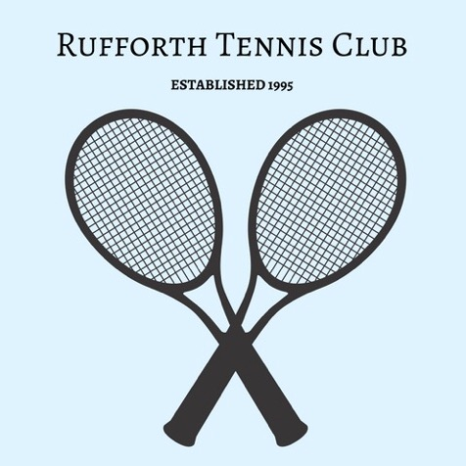

**Accident Reporting Policy**

* Stay calm but act swiftly and observe the situation. Is there any danger of further injuries?
* Listen to what the injured person is saying.
* If the injury is minor, use equipment from the first aid kit provided.
* If the injury requires specialist treatment, call the emergency services.
* If the injury has occurred during a junior group session, ensure the rest of the group are adequately supervised and reassured if necessary. It may be appropriate to contact another committee member to assist with this if possible.
* Do not move someone with major injuries. Wait for the emergency services.
* Contact the injured person’s parent/carer/relative (as appropriate).
* Complete an incident/accident report form (copies located on the internal notice board and in each first aid kit. In the absence of competitive matches these are currently held by Wendy Farnell, Andy Ivel, David Laws, Kate Lewis, Rob Berry and Liz Powell).
* Provide Wendy Farnell (Accident Reporting Coordinator - wendyfarnell@hotmail.co.uk) a copy of the accident report for recording in a central file and details of any items that need to be replaced in the first aid kit.
* The central file will reviewed annually for accident patterns or risk concerns that may need further consideration and inclusion in the club risk assessment.
* Accident forms are retained in locked box in a confidential manner at all times.
* This policy will be reviewed and updated annually by the Club Committee.

*Reviewed and updated: January 2023 Next review due: January 2024*