**COMPLAINTS AND WHISTEBLOWING POLICY**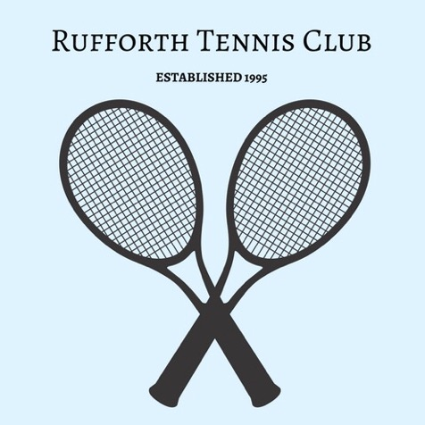

At Rufforth Tennis Club we aim to ensure a safe and inclusive environment for tennis to be played and strive to provide efficient services to a high standard at all times. We would like to hear about what we are doing well and areas where we can improve. We understand there are times you may not always be happy with our club. Therefore, your feedback is very important to us to ensure we continue to provide an excellent service.

This policy covers how you as a member can make a complaint and the process that will be followed and also can provide feedback and suggestions on any aspect of the club’s services.

The club takes complaints about conduct and behaviour very seriously and works in line with the LTA’s processes and procedures to respond to concerns.

This policy tells you how to make a complaint at Rufforth Tennis Club. This is the policy that we will follow if your complaint is about someone’s conduct or behaviour. This could be because you think that someone has behaved in a way that is unsafe, unprofessional, discriminatory, offensive or intimidating. It could also be because someone has broken important rules or policies.

**Values and principles**

We base our complaints policy on the following values and principles which are in line with the club’s Code of Conduct – Safeguarding, Inclusion and Diversity Policies are available in full on the website.

You have the right to complain: we take complaints seriously. You should not be harassed, bullied or put at a disadvantage because of making a complaint.

•Equality: you should receive a proper response to your complaint, regardless of your age, gender, disability, race, religion, nationality, social status, sexual orientation or political persuasion.

•Fairness: we believe that complaints should be dealt with fairly and openly. Unless it would put other people at risk, those affected by a complaint should have a chance to contribute and respond to any investigation.

•Safety and welfare take priority: we will always give priority to concerns that affect safety and welfare. Issues affecting children will be treated very seriously.

•Confidentiality: we treat complaints as confidentially as possible. Sometimes we have to discuss complaints with other organisations. If we are worried about a risk to a person or to the public, we might need to pass on our concerns to the right authorities. If necessary, we will get advice from other organisations such as the Police, Social Services or the LTA.

**How to make a complaint?**

If you have a complaint, it is often best to start by having a conversation with someone from within the club. This can be arranged as a verbal conversation or in person. You can also write to the relevant person below if it’s easier. It is easier for us to handle your complaint if you provide as much detail as possible. Depending on the nature of your complaint, you should contact the following individuals initially:

•Coaching matters – Head Coach/Club Secretary (Angela Crossley/Kate Lewis at

[acrossley@ac-tenniscoaching.co.uk](mailto:acrossley@ac-tenniscoaching.co.uk) or [rufforthtennisclub@gmail.com](mailto:rufforthtennisclub@gmail.com))

•General tennis matters – Tennis Club Chair (Andy Ivel at andyivel@hotmail.co.uk)

•Safeguarding matters – Welfare Officer (Sarah Skidmore at Sarah.skidmore@sky.com)

•Tennis Committee or other matters – Tennis Club Secretary (Kate Lewis at rufforthtennisclub@gmail.com)

You can send an email to the relevant officer or speak to them by phone. Contact details for members of the Tennis and General Committees are available on our website – www.rufforthtennisclub.co.uk

What will we do to investigate?

•We will give an initial response to your complaint within five working days. If the matter is urgent, we will respond more quickly.

•The contact may ask someone else on the coaching team or committee who manages a specific area of the club’s operations to look into the complaint.

•We will investigate your complaint fairly. This means that we will discuss the complaint with all of the relevant people involved. We will try to gather any information that may be relevant to handling your complaint.

•Sometimes we will ask to show copies of information from the investigation to other people to allow them to respond. This is because we believe in fairness and openness.

•We will not share information if we think that this will endanger someone’s safety or welfare.

•We will take into consideration data protection and privacy in all dealings with any complaint and therefore we will not pass on any personal information unless we receive permission from the complainant to do so. The club GDPR Policy will be adhered to at all times.

•Where the difference remains unresolved by the initial contact, further reference may be made to the relevant Committee

The Club will take reasonable steps to conduct a thorough investigation and will always give priority to someone’s safety and well-being. It is important to recognise that whilst we aim to resolve all complaints, in some situations we may decide we cannot investigate or take further action (i.e. this might be due to lack of information or detail). The club reserves the right to end any investigation or refer it to the LTA if required. If this happens you will be given the reasons for the club’s decision.

**How will I know what is happening?**

You will be given the details of a person who will be your point of contact for the duration of the investigation. That person will make sure that you understand the process involved, and will help to answer any questions or concerns that you have.

You will be given an update on the progress of your complaint every two weeks. If there are delays in handling your complaint for any reason, we will keep you informed. If your complaint leads to formal disciplinary action against someone, we will usually inform you about the outcome.

We will not tell you the outcome if that person is a child, or if we believe that telling you would create a risk to other people. In this situation, we will still try to tell you about how you are affected by the action that we have taken.

What are the possible outcomes or results of my complaint?

In many cases, we are able to resolve problems informally. This might include:

•A change in arrangements for particular activities

•An explanation or apology

•An agreement to communicate or act differently in future

•If an informal resolution is not suitable, then a small committee of club officials will look at the information about the case. We will try to make sure that this committee does not contain anyone directly involved with your complaint. They might decide to take the following action:

•Formal disciplinary action under the rules of the place to play

•Formal disciplinary action against a member of staff

•Changes in formal contracts or arrangements put in place by the place to play

•A decision to refer the case to another organisation such as the LTA, Police, or Social Services.

•Closure of your complaint without action

Is there anyone else I can talk to?

Sometimes it can be useful to speak directly to someone outside the place of play if:

•You need urgent advice about someone’s safety or welfare

•You don’t want to discuss the issue with someone at the club

•Your complaint is very serious

•Your complaint involves other organisations

•You need specialist advice

The LTA is able to advice on a range of different complaints, and in some cases will handle certain complaints directly.

If you are worried about a child or vulnerable adult’s welfare, you can contact the following people:

•LTA Safe and Inclusive Tennis Team 020 8487 7000 / safeandinclusive@lta.org.uk (Monday to Friday, 9am to 5pm

***Reviewed and approved January 2023***

***Next review due January 2025 (or earlier if there is a change in legislation)***