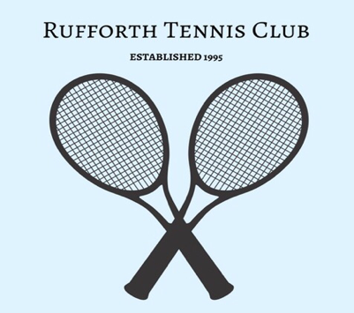**Safeguarding, Diversity & Inclusion Code of Conduct**

This document is to be read in conjunction with the Safeguarding, Diversity & Inclusion policies (which can be found in full on the club website – [rufforthtennisclub.co.uk](http://rufforthtennisclub.co.uk)) or for a copy please contact Kate Lewis at rufforthtennisclub@gmail.com.

All club officials, volunteers, members and others using the club facilities are required to abide by this Code of Conduct. This is required in order to support the club in providing a welcoming and safe environment for all children and young people and in the implementation of its safeguarding policy and procedures.

Everyone involved in the club should:

•Prioritise the well-being of all children and adults at all times

•Respect the rights, dignity and worth of every person within the context of our tennis club

•Display high standards of behaviour. Always work in an open environment (i.e. avoid private, or unobserved, situations). Act with integrity at all times

•Help to create a safe and inclusive environment both on and off court and promote the Fair Play values: enjoy; respect

•Place the well-being and safety of children above the development of performance

•Value and celebrate diversity and make all reasonable efforts to meet individual needs

•Keep clear boundaries between your professional and personal life, including on social media

•Check you have the relevant consent from parents/carers, children and adults before taking or using photos and videos

•Ensure your own roles and responsibilities, and those of everyone you are responsible for, are clearly outlined and everyone has the information, training and support to carry them out

•Where possible, do not be alone with a child or adult at risk (NB LTA guidance does allow for public 1 to 1 coaching as defined within the good practice guidelines)

•Coaches and volunteers must take positive action to protect both themselves and raise concerns if they feel uncomfortably placed in a position of working alone and/or unsupervised

•Do not abuse, neglect, harm or discriminate against anyone; or act in a way that may be interpreted as such

•Doing nothing is NOT an option: report all concerns and disclosures as soon as possible

*The Code of Conduct should be interpreted in a spirit of integrity, transparency and common sense, with the best interests of children and adults at risk as the primary consideration. Please contact our Welfare Officer - Sarah Skidmore if you have any concerns (see Welfare Officer Poster for more information).*

***Reviewed and approved: January 2023***

***Next review due: January 2025***